**Experiment 3.2: Data Acquisition and Filtering using LabVIEW Report**

**Title**: Experimental Study on Data Acquisition and Signal Filtering in LabVIEW

**Date**: 2024-12-06

**Name**: 徐安博 XU Anbo

**Student Number**: 202283890035

**I. Introduction**

This experiment aimed to demonstrate the process of signal acquisition and filtering in LabVIEW using DAQExpress and Filter Express. By following a series of steps, a signal was acquired from a data acquisition device and filtered to remove unwanted noise. The ability to accurately acquire and filter signals is crucial in many fields, such as electronics, instrumentation, and data analysis, as it allows for the extraction of meaningful information from raw data.

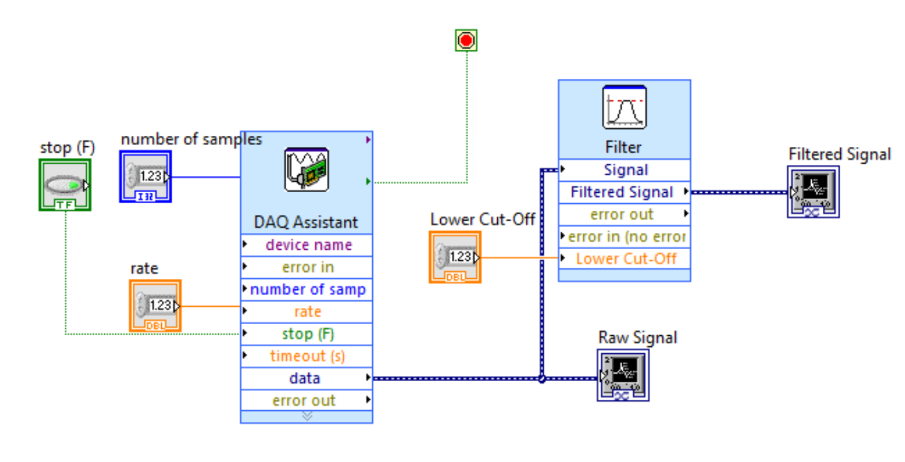

**II. Experimental Procedures and Results**

**Part 1: LabVIEW Setup and DAQ Configuration**

1. **LabVIEW Initialization**
   * LabVIEW was opened, and a new.vi was created by selecting File > Create New.vi.
2. **DAQ Setup for Data Reading**
   * The DAQ was set up to read data (analog voltage) into LabVIEW. From the Functions palette, Express Input > DAQ Assist was selected. The DAQ Assistant on the Block Diagram was double-clicked, and the appropriate settings were chosen for voltage acquisition. The terminal configuration was set to RSE, ensuring all grounds were connected together. The Acquisition Mode was set to Continuous Samples to continuously collect data. The number of samples to read was set to 50k, and the rate was also set to 50k.
   * The DAQ Assistant generated code, and a While Loop was either automatically created (if prompted and selected yes) or placed manually on the Block Diagram to allow the DAQ Assistant code to execute continuously.

**Part 2: Front Panel and Graph Creation**

1. **Graph Placement and Labeling**
   * On the Front Panel, two Waveform Graphs were placed. One was labeled as the Raw (Unfiltered) Signal, and the other as the Filtered Signal. These graphs would be used to visualize the original and filtered signals.

**Part 3: Software Filter Configuration**

1. **Filter Selection and Parameter Setting**
   * On the block diagram, a signal filter was placed by right-clicking and selecting Express > Signal Analysis > Filter. A lowpass Butterworth second-order filter with a cut-off frequency of 1200 Hz was configured. This filter was chosen to attenuate frequencies above 1200 Hz, aiming to remove the added high-frequency noise from the signal.

**Part 4: User Interface Configuration**

1. **Control Placement and Wiring**
   * On the front panel, numeric controls were placed to allow control of the sample rate, number of samples, and filter cut-off. These controls were wired into the appropriate variables in the block diagram. The controls were labeled for easy identification and interaction during the experiment.

**Part 5: Testing and Adjustment**

1. **VI Execution and Parameter Tuning**
   * The VI was run to test the program. The sample rate was adjusted to ensure good sample acquisition, at least capturing a full wave. The cut-off frequency was adjusted to effectively remove the noise from the signal. During testing, it was observed that the filtered signal showed a significant reduction in the high-frequency noise compared to the raw signal. The x- and y-axis scales of the graphs were adjusted as needed. By right-clicking on the charts on the Front Panel and selecting Properties > Scales, Autoscale was disabled for each axis, and an appropriate range was selected to better visualize the signals.

**III. Conclusion**

This experiment successfully demonstrated the process of signal acquisition and filtering using LabVIEW, DAQExpress, and Filter Express. The configured lowpass Butterworth second-order filter effectively reduced the noise in the acquired signal, as evidenced by the comparison between the raw and filtered signal graphs. The ability to adjust the sample rate, number of samples, and filter cut-off through the user interface provided flexibility in optimizing the filtering process. This experiment serves as a valuable practical experience in the field of signal processing and data acquisition, laying the foundation for further exploration and application of these techniques in more complex systems. Future work could involve testing different filter types and configurations, as well as integrating the filtered data into other analysis or control systems.